Washington DC

Presidential Past times

- George Washington never lived in DC. The White House was completed a year after he died and the second U.S. President, John Adams, was the first to live there.

- The White House has a total of 35 bathrooms.

- George Washington was supposed to be buried at the U.S. Capitol but his will stated that he wanted to be buried at his home, Mount Vernon, just outside of DC in Virginia.

- The original phone number for the White House in 1878 was simply the number 1. A phone wasn’t installed on the President’s desk in the Oval Office until 1929.

- The only president buried in DC is Woodrow Wilson, who is entombed at the Washington National Cathedral.

- When Abraham Lincoln stayed at the Soldiers’ Home during summers, he would often commute the four miles to and from the White House on horseback.
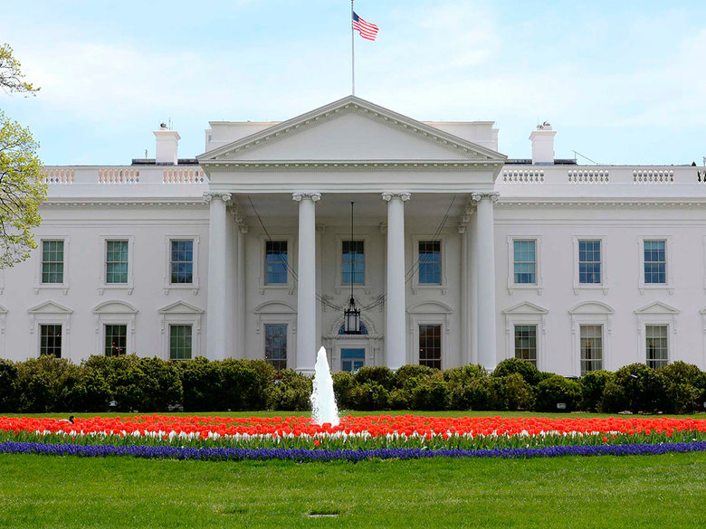The White House

Awesome First Animals

Cats and dogs haven’t been the only presidential pets to roam the White House grounds.

- Theodore Roosevelt allowed his six children to bring their pets to the White House in 1901. As well as many dogs they had a small bear, a lizard, guinea pigs, a pig, a badger, a blue macaw, a garter snake, a one-legged rooster, a hyena, a barn owl, a rabbit and a pony.

- Calvin Coolidge also brought a zoo-worthy lot of animals. Not only did he have many dog breeds including terriers, a sheepdog, collies and chows, he also had cats, racoons, a donkey, a bobcat, birds, a bear, an antelope, a wallaby, a pygmy hippo and some lion cubs.

- Not all animals at the White House have been pets. During World War I Woodrow Wilson bought a flock of sheep to graze on the White House lawn. Not only did it save the manpower needed for mowing the lawn, they sold the wool to raise money for the Red Cross.

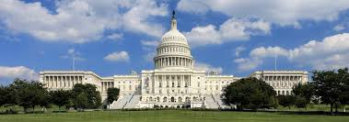
U.S. Capitol

Monuments, Memorials and Museums
- The Statue of Freedom is the bronze statue on the top of the U.S. Capitol dome. It looks small from afar, but it’s more than 19 feet tall and weighs nearly 15,000 pounds.

- The DC War Memorial , which honors local residents of Washington, DC, is the only memorial dedicated to World War I on the National Mall.

- When the Washington Monument opened in 1884 it was the tallest structure in the world, until the Eiffel Tower in Paris took the title in 1889.

- The Library of Congress is the largest library in the world with more than 162 million objects in its collection. This number is constantly growing with approximately 12,000 items added to the collections daily.
- You can look at the original Declaration of Independence, U.S. Constitution and Bill of Rights at the National Archives.

- The National Mall is a work in progress. Martin Luther King, Jr. Memorial is one of the newest memorials, having opened in 2011 and the American Veterans Disabled for Life Memorial was unveiled in 2014.

Facts and Figures

- The Maine Avenue Fish Market has been operating nonstop since 1805, making it the oldest continuously functioning fish market in the country.

- The cherry blossom trees that line the Tidal Basin and have beautiful pink blooms every spring were a gift from the mayor of Tokyo in 1912.

- Georgetown is the oldest part of the city, dating back to 1751 — 40 years before Washington, DC was founded.

- Bill Gates and Katherine Heigl were both born in Washington.

What to do:

- Make a list of ten words from the text and translate into Swedish. Use bab.la.
- Write 10 questions to the text.
- Find out two more “fun facts” about Washington DC, about the White House, the history or one of the presidents. Write twp short paragraphs.

