Five Refugee Athletes on their way to the Olympics in Rio

- Before reading the text, find out what these words mean: “depart,” “persecution,” and “deprived”.
- Find 10 difficult words and translate them into your language.
- Write 5 reasons that you can find in the text why the Refugee Team matters to so many people.
- Do you think of any other reason? Choose one reason and write about why you think that is an important reason.

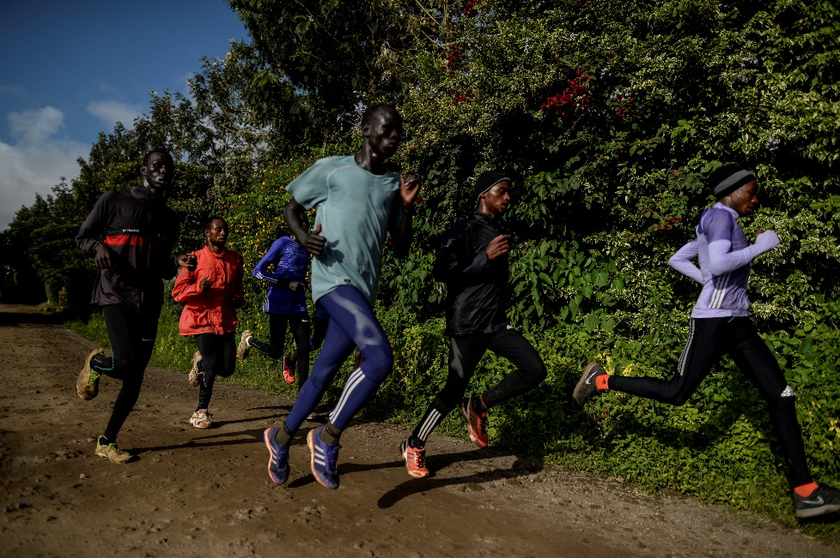
Refugee athletes set out for Rio Olympics, and history
Five middle-distance runners from South Sudan, until recently living in Kenya's Kakuma refugee camp, to take part in first-ever Refugee Olympic Team.

A group of young African refugee athletes left Nairobi, Kenya, for the Rio Olympics, making history as they embarked on their journey. Among them were five middle-distance runners from South Sudan who had been living in Kakuma refugee camp in northern Kenya. They departed with joy, receiving a warm send-off filled with hugs, songs, and encouragement from friends, fellow refugees, and supporters.
The five will join five others from Syria, Democratic Republic of the Congo and Ethiopia to make history by taking part in the first-ever Refugee Olympic Team.
“I feel very excited. This is the first chance for the refugees to participate in the Olympics and to give us hope, for us to encourage the young generations of fellow refugees who are remaining in the camps maybe to continue their talent,” Rose Nathike Lokonyen, 23, told UNHCR in an interview prior to departure.
“The 10-member team will act as a
symbol of hope for refugees worldwide.”
The 10-member team, backed by UNHCR and the International Olympic Committee, was created to bring global attention to the magnitude of the global refugee crisis and act as a symbol of hope for refugees worldwide, deprived of the opportunity by conflict and persecution, of representing their countries or even often playing sport at all.
The five South Sudanese, two women and three men, have spent the last few days in Nairobi in enhanced training sessions so as to arrive in Rio in peak condition while at the same time preparing for the trip of a lifetime – a trip which until a few months ago was beyond their wildest dreams.
Most fled civil war in Sudan over 10 years ago. Apart from fleeing into exile, they have not travelled out of Kenya. They have lived and grown up in the remote Kakuma camp, where there are few modern facilities for youth, and running proved a welcome distraction from the hardship of daily life.
‘We have a message to tell the world: We have come as refugees, we have come as ambassadors for refugees, now we are here to show you that we can do everything other human beings can do, and also be part of a peace promotion around the world,” said Yiech Pur Biel, 21.
Yiech, who will run in the 800 metres, has trained with some of his heroes in the Kenyan athletics team and has made huge improvements in his timings within a matter of months. He was 11 years old when he arrived at the camp without his immediate family, who fled in another direction to Ethiopia and whom he has not seen since.
"It gives me hope to continue to train and to work hard."
“It gives me hope to continue to train and to work hard and then to be a champion one day, and one time to represent my country, because I will not be a refugee for ever and I know that,” he added.
UN High Commissioner for Refugees Filippo Grandi has praised the young athletes.
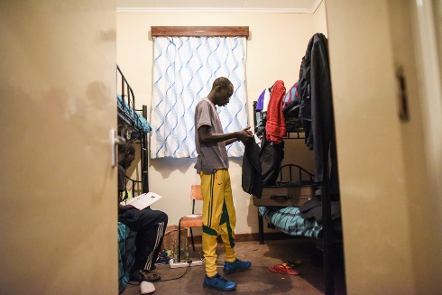
“Their participation in the Olympics is a tribute to the courage and perseverance of all refugees in overcoming adversity and building a better future for themselves and their families,” he said in a recent statement.

© UNHCR/Benjamin Loyseau
James packs his belongings before departure for Rio, where he will compete in the 800 metres.

Officially, the athletes will compete for the Refugee Olympic Team and march with the Olympic flag immediately before host nation Brazil at the Opening Ceremony.
Like all teams at the Olympic Games, the refugee athletes will have their own entourage to meet all the required technical needs of the athletes. Olympian and former marathon world record-holder Tegla Loroupe of Kenya was named the team’s Chef de Mission, while Isabela Mazão of Brazil, who was proposed by the UNHCR, will act as the Deputy Chef de Mission. They will lead a crew of five coaches and five other team officials.
Meet all the members of #TeamRefugees here.

Source
UNHCR. (2016, July 29). Refugee Olympic team makes history at Rio Games. United Nations High Commissioner for Refugees. https://www.unhcr.org/news/stories/refugee-olympic-team-makes-history-rio-games

