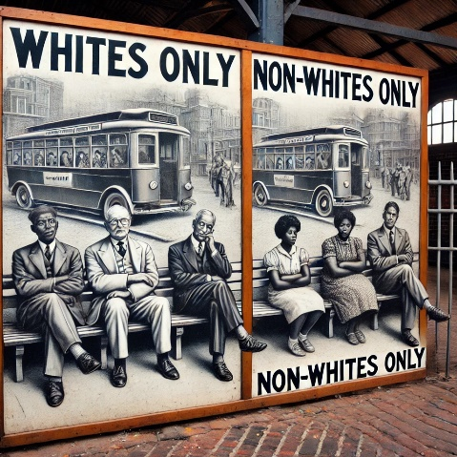
Apartheid
Apartheid was a system in South Africa (1948–1994) that separated people by race. White people had more rights, while Black people and others were treated unfairly. They had to live in different places, go to separate schools, and had fewer opportunities. Apartheid ended in 1994 when Nelson Mandela became the first Black president and improved the situation.

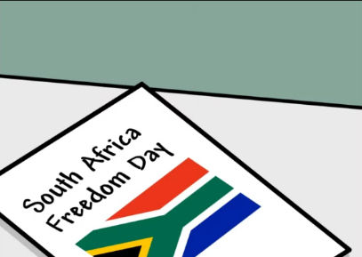
In the video below you will learn more about Apartheid and its end, which led to the celebration of Freedom Day in South Africa.
https://edpuzzle.com/media/61dcc38c90a32b429ad070af

Take some time to answer the questions in the table below to gather information about apartheid and South Africa. You will revisit this table later to add more details.

What does apartheid mean?

What were the three main racial groups during apartheid?

How were Black people treated differently from white people under apartheid?

What happened to those who resisted apartheid?

What were important steps to ending Apartheid?

Why is April 27 considered Freedom Day?

Here is another video to gain an even better understanding of what Apartheid is.
https://www.youtube.com/watch?v=ke4kVFycpYY
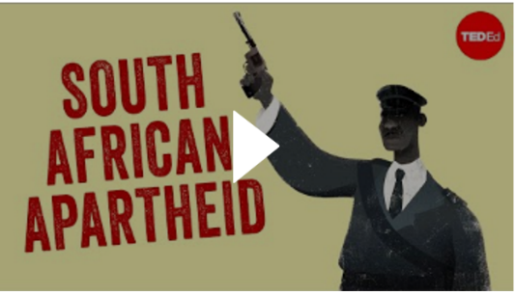

Once you have watched the video, you can update the table with any new information you have learned.


In the following video, Trevor Noah, a South African comedian and actor living in the U.S., visits his grandmother in Johannesburg, South Africa. Listening to her share stories about his childhood during Apartheid offers an insightful perspective.
https://edpuzzle.com/media/67a6447fbbc3b1b8d24b7845

When you and your table mate both are done with the tasks above, take a look at these questions and discuss them with the peer next to you.
- Now that you have seen a few videos and learnt a little more, what is really Apartheid?
- What did you think was interesting about the videos?
- What surprised you?
- What would you like to learn more about?
- Does the situation in South Africa remind you of any other context? If you think so, in what way?
- What do you think South Africa is like today?

Do you still have time left or want to learn more? Here is yet another video about the apartheid that you may just enjoy watching or use to add more information to the table.
https://edpuzzle.com/media/614f71e9f906db417347d150
