Greta Thunberg
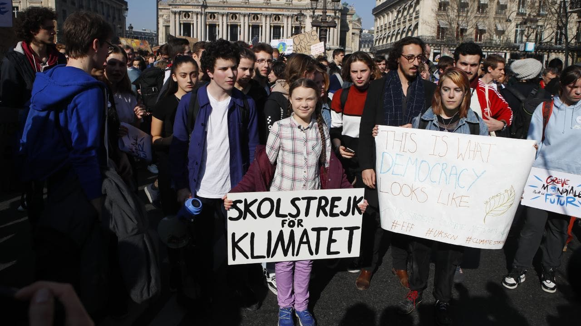
Students from more than 70 countries are planning a massive global protest this Friday against inaction on climate change, led by Swedish schoolgirl Greta Thunberg. It could be one of the biggest environmental protests the world has ever seen.
Greta began a weekly “school strike for climate” on August 2018. Then, 15, Greta rode her bicycle to sit on the cobblestones in front of Stockholm’s Parliament House with a handpainted sign that said “skolstrejk för klimatet”, which is “school strike for climate” in Swedish.
Thousands of students around the world have since copied her. Youth organisations are calling for a strike on Friday and Greta understands there will be more than 700 protest locations.
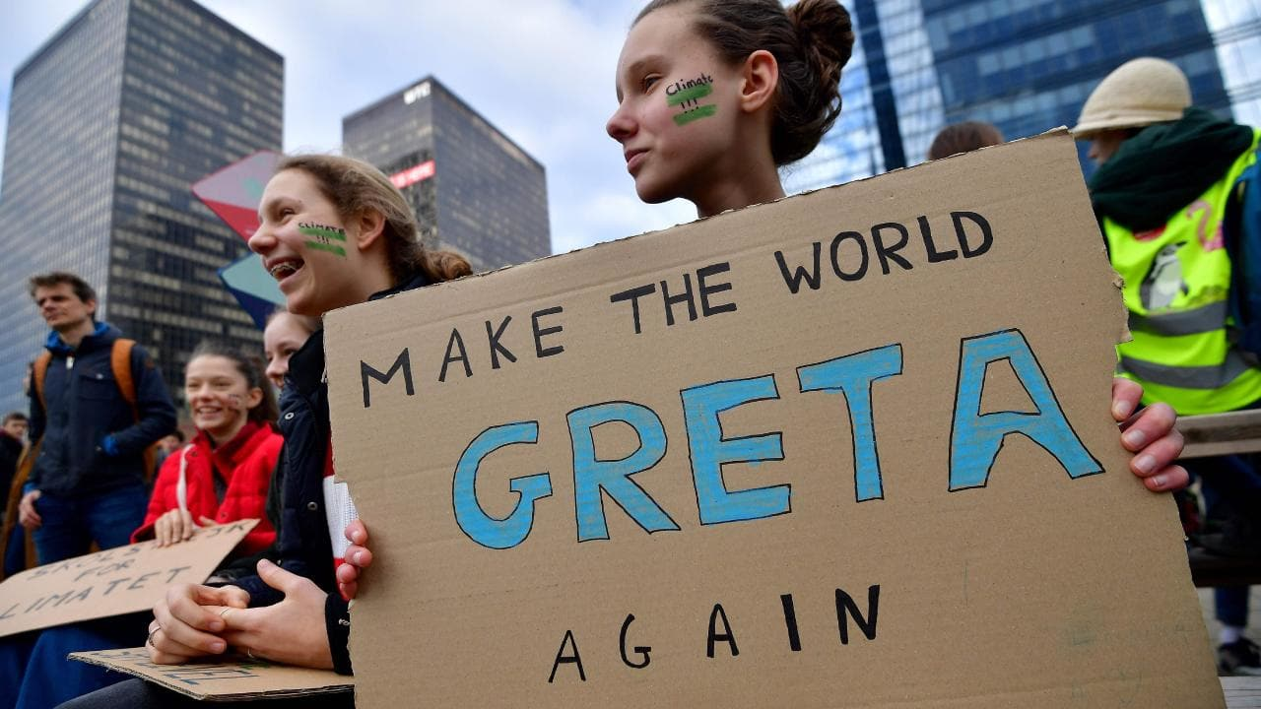
“I think this movement is very important. It not only makes people aware, and makes people talk about it more, but also to show the people in power that this is the most important thing there is.”
Greta has more than 250,000 followers on social media platform Twitter where her movement carries the hashtags #FridaysForFuture and #SchoolStrike4Climate.
“I think the most fun thing is to watch all the pictures around the world of hundreds of thousands of children school striking for the climate.”
A TEDx talk she delivered on climate change now carried on TED’s main website has had more than 1million views. Besides Twittering and school striking Greta has also joined protests in other countries, such as Belgium, where she won a European Union pledge to spend billions of euros to combat climate change.
Greta has also had an impact on her parents, author and actor Svante Thunberg and opera singer Malena Ernman. Inspired by their daughter’s concern for the environment, the pair have stopped flying and have adopted vegan diets as part of their efforts to live more environmentally sustainable lives.

The Paris Agreement
The Paris Agreement is a 2015 document signed by 195 countries. The goal of the United Nations Paris Agreement is to keep the increase in global average temperature to well below 2C above pre-industrial levels and to limit the increase to 1.5C, since this would reduce the effects of climate change. Under the agreement, each country must plan for and report on what it is doing to limit global warming.
Sweden, Greta’s home country, is a signatory to the Paris Agreement, and as a country Swden is working hard to fulfill its obligations. The question is, however, if Sweden is doing enough?
“I’ve said that I will continue to strike every Friday until Sweden is in line with the Paris Agreement,” Greta says. “That may take a couple of years and I’ll just have to try to be patient.”

Australia is also a signatory to the Paris Agreement. There is, however, much disagreement among Australians, including politicians, business people and scientists, about whether Australia is doing enough to meet its Paris Agreement targets and how best to do so.
I 2019 the United States of America exited the Paris Agreement, claiming that the agreement was a threat to American jobs and American economy as a whole. The United States of America produce nearly one fifth of the global emissions, and it is there for a great loss to the agreement. USA is the first country to leave the agreement, but hopefully no other country will follow.
In 2019 Greta sailed in a racing yacht from the UK to north America to participate in a United Nations-sponsored climate negotiations meeting that was to take place in Chile. Due to massive protests, however, the venue of the meeting had to be changed on short notice, to Madrid in Spain. That meant that Greta once again had to sail across the Atlantic, this time in a Catamaran sailed by a an Australian couple and their 11-month old baby. Greta refuses to fly, and tries to travel as environment friendly as possible.

