Scotland
Scotland

Did you know that Scotland produces more than 250 million litres of whiskey every year? That's enough to fill 4,546 average size swimming pools, not bad! It might not be so surprising after all, considering that whiskey is the Scottish national drink.
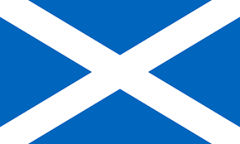
Here are some more facts about Scotland that may be a bit more dry:
Scotland is a country in the north of Europe, and has since 1707 been a part of Great Britain, along with Northern Ireland, Wales and England.

The capital of Scotland is Edinburgh, although Glasgow is the largest city. Just over 5 million people live in Scotland. The weather is cold most of the year, and Scots get quite a bit of snow during the winter. A lot of people spend their winter holidays skiing. The summers are warmer, and the average temperature is almost 20°C.

When it comes to scenery, Scotland is distinguished from the rest of Great Britain by their mountains, lochs, brooks and dramatic coastline. At 1,343m, Scotland's Ben Nevis is the highest mountain in Britain.

It also has the largest lake, Loch Lomond. Scotland is also the home of Britain´s most famous sea monster, Nessie who is said to live in the lake named Loch Ness, the deepest lake in Great Britain.

The Language
The language situation in Scotland is quite complex. Three language varieties exist in the country; first there is Scottish English, which is really an English dialect with a regional accent. This is the dialect we usually hear on TV whenever there is a Scotsman present. Then we have another variety of English with a much older origin. This is Scots or Lallans which springs from the old Anglo-Saxon. Finally there is Scottish Gaelic ,one of four Celtic languages to survive into modern age, the others being spoken in Brittany, Wales and Ireland.

Four Things to Enjoy While in Scotland

Celebrate Hogmanay, which means New Year’s Eve celebration. The Scottish know how to celebrate New Year's with this festival, sometimes starting a few days before the 31st and lasting until January 2nd. Any city will do, although Edinburgh makes a special effort each year with a massive street party and famous bands playing.

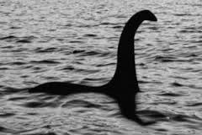
Attend a ceidlih. This is a gathering where they play traditional folk music and dance. There is a band playing and a so called dance caller will teach novices the steps of each dance before the music begins. The more versatile bands will demonstrate the dances too. Bands vary in size but are commonly made up of between 2 and 6 members. The appeal of the Scottish cèilidh is by no means limited to the younger generation, and dances vary in speed and complexity to suit most age groups and levels of ability.
Experience the festival Up Helly Aa. It takes place on the last Tuesday of January in Lerwick, Shetland, to mark the end of the yule season. Yule is an older word for Christmas. This is Europe’s biggest fire festival and involves up to a thousand men dressed in costumes walking in a procession through town with torches and ending in the burning of a Viking Long boat.

Visit the Isle of Skye in the Scottish archipelago. The largest island of the Inner Hebrides is renowned for the rugged and beautiful scenery. Here you can see the Old Man of Storr, a magnificent rock eroded by the sea, which is completely unique. I bet the scenery would make you feel like you're on the set of a fantasy film.

Some Fun Facts about Clothes

Do you have a mac? No, we’re not talking about the computer! The Mackintosh, abbreviated as mac or mack, is a form of waterproof raincoat, first sold in 1824, made out of rubberized fabric. The Mackintosh is named after its Scottish inventor Charles Macintosh.

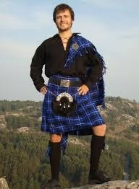
Some people in Scotland play the bagpipes and wear a kilt. The kilt is a knee length pleated skirt worn by men. It is made from wool and has a tartan design. Each clan had its own tartan pattern.

What about the rumour of Scotsmen not wearing any underwear under their kilts? Well it is true! Kilts have been traditionally worn without undergarments since their use as part of Scottish military uniform, leading to the invention of such expressions as "going commando" or "military practice" for wearing no underwear. Back in the day, military leaders actually had mirrors tied to the end of golf clubs or walking sticks to inspect up and under the kilt at parade inspection!
The matter of not wearing underwear is also humorously called being a true Scotsman.

Answer these questions.

Is the capital Edinburgh also their biggest city?
Where does Nessie live? In the deepest or the largest lake?
In which areas are the four Celtic languages still spoken?
What is Hogmanay celebrating?
What does the festival Up Helly Aa put an end to?
What can you learn at a Scottish cèilidh?
What is an archipelago?
What fabric is a kilt made of?
Which three expressions are used about not wearing any underwear under a kilt?
What is a mac?

