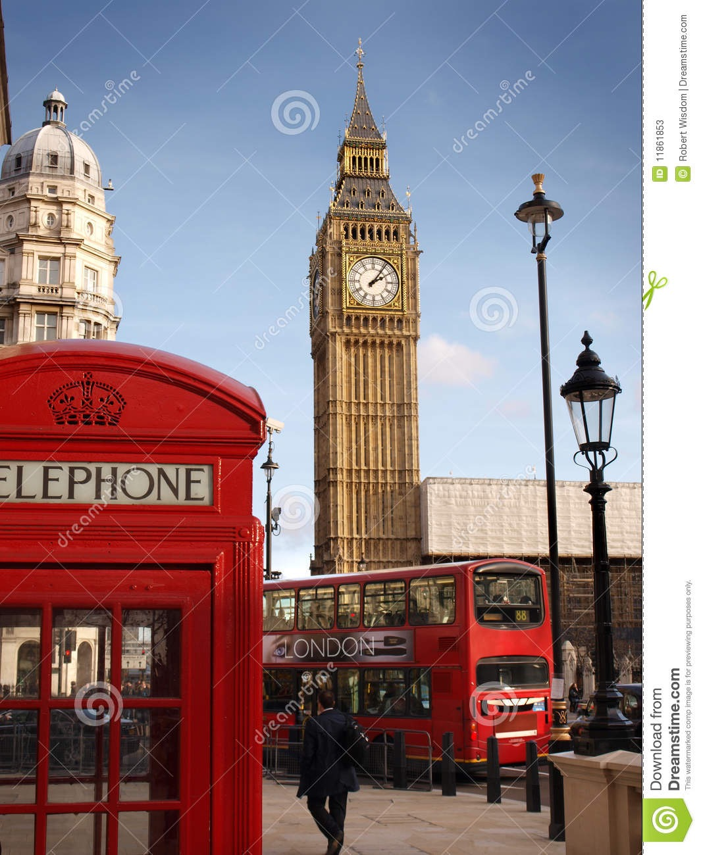
London
Some Facts about London

PART 1 - Read the text and summarize it IN SWEDISH with your friend.

Did you know that if London were a country, it would be the 8th largest in Europe? Pretty amazing, right? There are just over 8.3 million people living in London, according to the latest statistics. Many people move here from other parts of the UK, but also from other countries. 25% of the people living in London today are born in another country. The Swedish embassy estimates that around 50,000 of them are Swedes.

London is famous for many things. One of them is the London Underground which is the oldest in the world. It opened in 1863. Nowadays, people usually just call it the Tube because of the shape of the tunnels on many of the lines. It has 270 stations all over greater London and there are 409 escalators. Many buskers like to perform there!

Blue Plaques

On some buildings in London you might see a blue plaque with a name and a year. These signs are there to show that a famous person has some connection to the house. They may have been born there, lived there, worked there or even died there.
The person mentioned on the sign has to be famous in some way but you might not have heard of them at all. In London they’ve been putting up these particular signs since the 19th century which means that some of them are really old.

Some of these you might recognize are Sherlock Holmes in Baker Street, Bob Marley in Ridgmount Gardens, Charlie Chaplin in Kennington Road and Isaac Newton in Jermyn Street.

Trafalgar Square
One famous tourist attraction is Trafalgar Square in the centre of London.
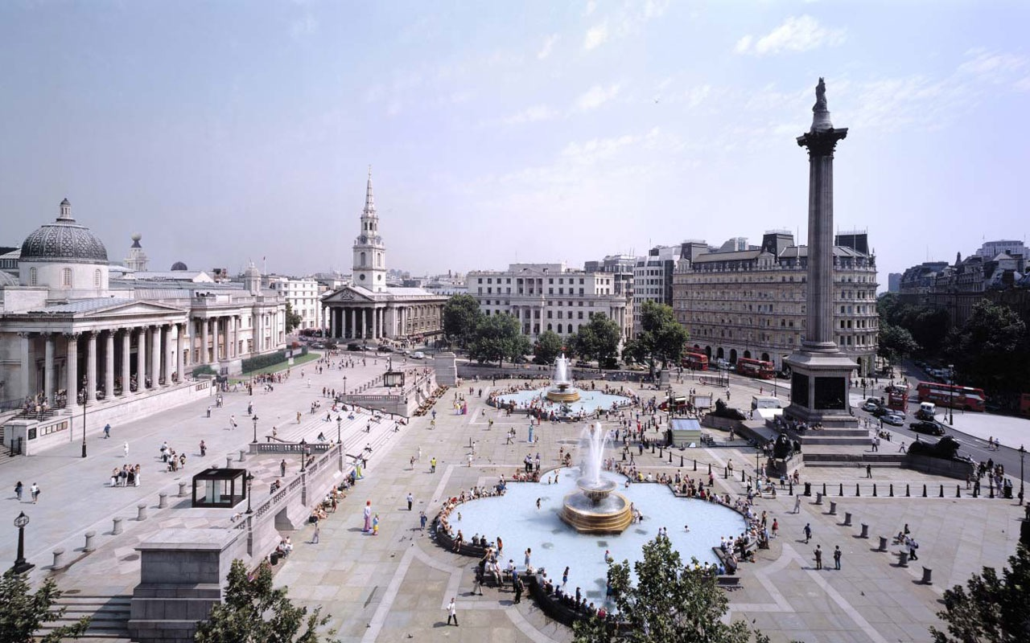
In the square there is a statue of Lord Horatio Nelson. Admiral Nelson was an English war hero. He won several battles for Britain, most notably the battle of Trafalgar in 1805 which cost him his life. To be able to transport the body back to England without it decomposing they kept it in a casket of brandy. The sailors aboard knew this, and legend has it they wanted the brandy so badly that they didn’t care there was a body lying in it. When they got back to England, there was no longer any brandy in the casket. Lord Nelson was buried in St Paul’s Cathedral.

The National Gallery is situated along one side of the square; It is a famous art museum where you can see paintings by Rembrandt, Michelangelo, Da Vinci, Van Gogh and many others. Sometimes they show a piece of art right outside the museum as well.
Every Christmas there is a big Christmas tree in the square. The tree is a gift from Norway as a thank you for the support that Britain gave them during World War 2.

After it was decided that London would host the Olympic Games in 2012 a countdown clock was placed in the square. It showed how many days, hours, minutes and seconds remained before the games would start.

PART 2 - READ the text. There are a few words underlined. Make a list of these words and translate them to Swedish. THEN compare your list with your friend.

Buckingham Palace
Buckingham Palace is where the Queen lives. Buckingham Palace is the Queen's official and main royal London home. It has been the official London residence of Britain's monarchy since 1837. Queen Victoria was the first monarch to live there. The Queen has other homes too, including Winsor Castle and Balmoral in Scotland.
Buckingham Palace is not only the home of the Queen and Prince Philip but also the London residence of the Duke of York (Prince Andrew) and the Earl and Countess of Wessex (Prince Edward and his wife) and their daughter.
Buckingham Palace is used also for the administrative work for the monarchy. It is here in the state apartments that Her Majesty receives and entertains guests invited to the Palace.

History of Buckingham Palace
Buckingham Palace was originally a grand house built by the Dukes of Buckingham for his wife. George IV began transforming it into a palace in 1826.

The Royal Flag
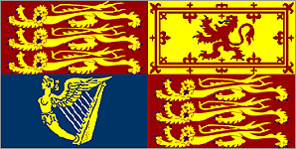
When can we see the flag on the pole?
When the Queen is at home, you can see her royal flag flying from the flag pole on top of Buckingham Palace. This flag is called the Royal Standard.
The flag is split into four quadrants. The first and fourth quadrants represent England and contain three gold lions walking (passant) on a red field; the second quadrant represents Scotland contains a red lion standing on the left hind foot (rampant) on a gold field; the third quadrant represents Ireland and contains the gold Coat of arms of Ireland on a blue field.
In flag protocol, the Royal Standard is supreme. It must only be flown from buildings where the Queen is present. It flies above the British Union Flag (Union Jack), Standards of other Royal Family members, and other British flags. It never flies at half staff.

Foot Guards
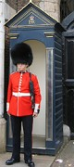
Who guards the palace? What do they wear? Five regiments of Foot Guards guard the Palace. They wear red jackets and tall, furry hats called bearskin. When the first guards come on duty, there is a ceremony called the Changing of the Guard. A familiar sight at Buckingham Palace is the Changing of the Gards ceremony that takes place in the forecourt each morning. The monarch and the royal palaces have been guarded by theHousehold troops since 1660.

Inside Buckingham Palace
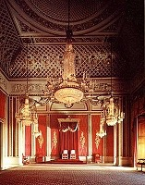

What can you see inside Buckingham Palace?
The Palace has around 600 rooms, including 19 State rooms, 52 royal and guest bedrooms, 78 bathrooms, 92 offices, a cinema and a swimming pool. It also has its own post office and police station.
About 400 people work at the Palace, including domestic servants, chefs, footmen, cleaners, plumbers, gardeners, chauffeurs, electricians, and two people who look after the 300 clocks.
Every year, more than 50,000 people come to the Palace each year as guests to banquets, lunches, dinners, receptions, and Royal Garden Parties.

