The Reptilian Elite
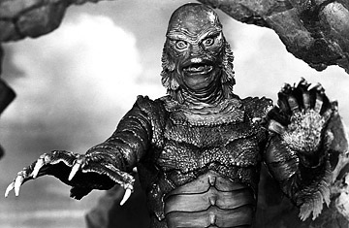

They are among us. Blood-drinking, flesh-eating, shape-shifting extraterrestrial reptilian humanoids with only one objective in their cold-blooded little heads: to enslave the human race. They are our leaders, our corporate executives, our beloved Oscar-winning actors and Grammy-winning singers, and they're responsible for the Holocaust, the Oklahoma City bombings and the 9/11 attacks ... at least according to former BBC sports reporter David Icke, who became the poster human for the theory in 1998 after publishing his first book, The Biggest Secret, which contained interviews with two Brits who claimed members of the royal family are nothing more than reptiles with crowns.

The conspiracy theorist and New Age philosopher, who wore only turquoise for a time and insisted on being called Son of God-Head, says these "Annunaki" (the reptiles) have controlled humankind since ancient times; they count among their number Queen Elizabeth, George W. Bush, Henry Kissinger, Bill and Hillary Clinton and Bob Hope. Encroaching on other conspiracy theorists' territory, Icke even claims that the lizards are behind secret societies like the Freemasons and the Illuminati. Since earning the dubious title of "paranoid of the decade" in the late 1990s, Icke has written several books on the topic, including his latest work, The David Icke Guide to the Global Conspiracy, while operating his own website — complete with merchandise and advertisements.

So where do they come from?
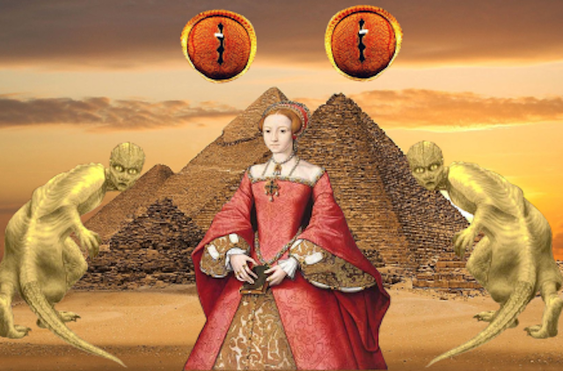
There are two schools of thought on where the Reptilians came from. Some believe that they evolved here on Earth, left Earth after they mastered intergalactic travel, and then returned millions of years later. Others believe their home planet is in the Draco constellations. Supposedly, they came to Earth thousands of years ago and shared the Earth with people. Then they either decided or were forced to go “undercover” and hid themselves from our reality. They also started to interbreed with humans by altering our DNA, similar to the way that people alter computer code.

This altering of our DNA had a twofold effect. They altered our DNA so we don’t use our brain to its full capacity, putting a limit on our consciousness, and making us easier to control. As evidence, Icke points to the fact that we have reptile genes within our brain. In fact, the Reptilian brain is the oldest of the three parts that control the brain. The second is that people with reptile DNA in them can be possessed by Reptilians who live outside our realm of awareness in the lower fourth dimension. These human-reptile hybrids, considered demigods, were able to gain power in the ancient civilizations of Sumer, Babylon, and Mesopotamia. As humankind started to colonize the rest of the planet, the reptiles spread across the Earth and became the royal families throughout the world.

By having power in every single country, the Reptilians have created a global prison that people don’t even realize they’re in. The prison was created by drawing country lines, which leads to endless wars and conflicts. Another way they control humans is by distracting us with media, entertainment, and even politics. They’ve also made the population stupid and lazy by poisoning food, the air, and the water.

So just to sum it up, because it’s a lot of very unusual information to take in: essentially, the lizard people altered our brains to limit their ability. They installed most, if not all, world leaders throughout history. Those leaders, in turn, contributed to all major historical events. Finally, for thousands of years they’ve been poisoning humans. And all of this was done to ensure that they control humankind. So right off the bat, the answer is yes, we’re taking a drive to crazy town right about now. Enjoy the ride!

How would you recognize one?

Some general characteristics of the Reptilians in disguise and people with Reptilian DNA is that they are usually Caucasian and have piercing eyes that are green, hazel, and sometimes blue, but they can also change color. They also have low blood pressure and unexplained scars.
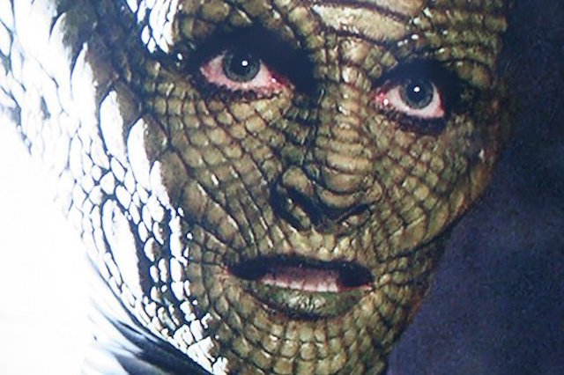
Since they hide from humans, it may be impossible to see them, but one thing you should look for is how they act. Often Reptilians and crossbreeds lack empathy, don’t express love easily, are incredibly smart, and have a love for space and science.

But, if you are desperate to try and see one: supposedly, if you watch television in slow motion, you can get glimpses of the Reptilians’ true identity. Sometimes the image can be distorted and skin looks scaly or green. Teeth become distorted and their eyes look like those of reptiles. There are plenty of videos on YouTube of people who claimed they have footage of Reptilians shape shifting.

Suspected reptilians

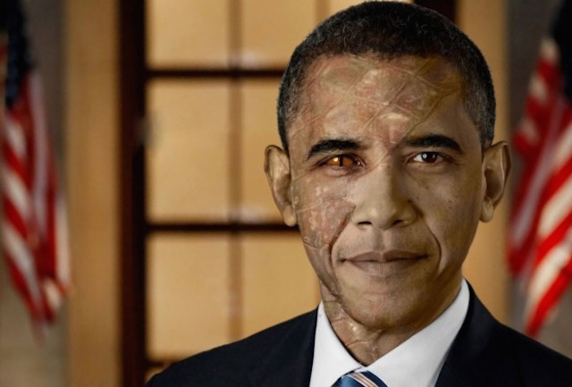
There are a number of famous people who are suspected of being Reptilian. This includes such notable families as the Rockefellers in the United States, the Rothschild family from Germany, and the British House of Windsor. It’s also believed that many of the Presidents of the United States are Reptilian, including the Bill Clinton (and Hillary Clinton, who is apparently higher than Bill in the Reptilian Hierarchy), Barack Obama, and both Presidents Bush. In fact, the Bushes are an integral part of the conspiracy because of how many famous people are related to them.

According to Ancestory.com, George W. Bush and Obama are 11th cousins and Dick Cheney is his ninth cousin once removed. Other blood relatives directly related to the Bushes include Abraham Lincoln, Marilyn Monroe, Pocahontas, Hugh Hefner, John Kerry, Vlad the Impaler, and Princess Diana. That means that, possibly, all of those people are actually Reptilian as well.

Not only have the Reptilians infiltrated banking, government, and the world’s royalty, but they are also some well-known and beloved entertainers like Bob Hope, Brad Pitt, and Angelina Jolie. Needless to say, with so many possible Reptilian people among us, it makes it hard to trust anyone. You could even be a Reptilian and not even know it.

Blood


Blood is very important to the Reptilians. For one thing, they apparently consume it. They also eat parts of human brains and apparently prefer children, because they aren’t as full of poison as adults. Besides just eating our blood, bloodlines are also an important feature in the Reptilian conspiracy. You can supposedly tell if someone is Reptilian by tracing their bloodlines. It’s believed that around 4800 BC the crossbreeds emerged from the mountains of Turkey, Iran, and Kurdistan and started the early civilizations of Sumer, Egypt, Babylon, and the Indus Valley.

This explains how humans became civilized and accomplished some amazing things: the crossbreeds kickstarted them. Thanks, lizard overlords! From these civilizations, humans began to migrate and the Reptilians went with them. So Icke claims that all the bloodlines of the supposed Reptilian people listed above can be traced back to this area.

Icke also says that there are markers in some people’s physical blood as well. He points out that from the area of the world where the hybrids originated, there are more people with an incredibly rare blood type called Rh and Rh negative. Other than just being rare, when a baby is born with Rh blood, their skin turns blue, and this is supposedly where the term “blue blood” comes from

The Reptiles and the Illuminati

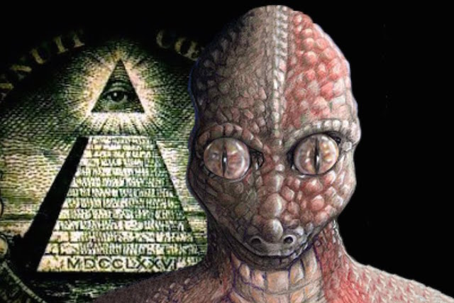
One of the most well-known “secret” societies is the Illuminati and according to some theorists, they are controlled by the Dracos. This idea was put forward by a man named Stewart Swerdlow, who claims he was a survivor of the Montauk Project. In his book, Blue Blood, True Blood: Conflict & Creation, he claims that there are 13 “Royal Families” of the Illuminati. The leader of the Illuminati is called the Pindar, which is shortened from Pinnacle of the Draco, and is a purebred Reptile.
According to Swerdlow, the Pindar is the head of the Rothschild family, who has been the Pindar for centuries. The 12 other families, all of them incredibly powerful, influential, and rich, have different areas of expertise, and they control global finances, military technology and development, mind-control, religion, and the media. All of the 13 ruling families are full-blooded Reptilians, but the class of individuals who support the 13 families, called the Committee of 300, are not. In fact, some of them do not even have any Reptilian DNA, though most do. The Committee of 300 supports the 13 families by controlling the organizations like the NSA, the CIA, Interpol, and the Mafia, just to name a few.

