Australia
General Facts

Australia is the largest island and the smallest continent in the world. It covers three time zones and is seventeen times bigger than Sweden.

According to the annual HumanDevelopment Report from UNDP, Australia is a great country to live in. It currently holds second place, only Norway is ranked higher. Sweden is number eight on the list.

The capital of Australia is… Canberra! If you guessed Sydney, you are not the only one, it’s a common mistake people make. Sydney is the largest city though, followed by Melbourne. Melbourne has the second largest Greek population in the world, after Athens, Greece.
Australia holds many impressive records. One of which is that it has the world's largest cattle station, or ranch. At 30,028 km2 it's almost the same size as Belgium! It's called Anna Creek station and it is located in South Australia.

Weather
Australia is generally known for its many hours of sunshine, but it is a continent that experiences a variety of climates due to its size. There is not one single seasonal calendar for the entire continent. Instead there are six climatic zones and two main seasonal patterns; There is a four season pattern in the temperate zone and a wet/dry pattern in the tropical north. The Australian Alps, also known as the Snowy Mountains, receive more snow than Switzerland.

A Famous Landmark

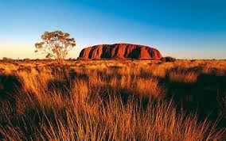
In the middle of the country is the famous Ayers Rock. Ayers Rock is the most commonly used name for this landmark, especially outside Australia. However, Uluru is its Aboriginal and official name, referring to both the rock itself and the waterhole on top of the rock. It stands 348 metres and is located very close to the actual geographical centre of Australia.
If you would like to walk around it, it will be a trip of 9.4 kilometres. If you ever do, be sure to bring a cold beverage because in the middle of summer i.e. December to March, the average temperature high is 38°C.
As a tourist, you are kindly requested not to climb Uluru, since it’s considered a sacred place to the Aborigines, the natives of Australia.

Sweet Animals

Australian kangaroos are the most famous Australian animals, and the kangaroo is one of the most recognisable icons in the world. If you imagined that kangaroos are hopping all over Australia, you are actually correct. These jumping creatures, more casually referred to as “Roos”, can indeed be found in all parts of Australia, not just in the Outback. There are over 60 different species of kangaroos.
The adult male Kangaroo is called a buck, boomer or jack, while the female is called a doe, flyer or jill. The young kangaroos are called joeys. The joeys initially live and drink milk in the pouch of the mother, like all marsupials. The older they get, the more time they spend outside the pouch, until they are too heavy to be carried around. Just like human babies, it often takes them a while to accept that they are too old to be carried everywhere....

Another well-known animal of Australia is the sheep. There are more than 150 million sheep in Australia and only about 22 million people! Nowadays, lamb has become an increasingly important product as the sheep industry has shifted its focus from wool production to the production of prime lamb.
An animal that you perhaps don’t associate with Australia is the camel. But Australia has the world's largest population of wild one-hump camels, also known as dromedaries.
There are about 350 species of termites in Australia. Termites are also called white ants, although they're not ants. As a matter of fact, they are not even closely related to ants. Termite mounds are the tallest non-human constructions on earth.

Dangerous Animals

Everybody fears snakes in Australia. Not only travelers, but also most of the locals, are absolutely terrified of snakes. There are about 140 species of land snakes in the country. Some are equipped with venom more toxic than any other snakes in the world.
Snake bites are actually quite rare in Australia and, since the development of anti-venom, fatalities have been low - between four to six deaths a year. "This is in contrast to India, for example, where bites may reach one million a year, resulting in over 50,000 deaths," says Associate Professor Bryan Fry, an herpetologist and venom expert at the University of Queensland. "Snake bites are very, very rare in Australia and often the fault of the person being bitten. Most bites occur when people are trying to kill a snake or when showing off."

Many people are also afraid of spiders. If you are one of them, you might feel uneasy knowing that the average person swallows three spiders a year! There are 1,500 species of Australian spiders. Regardless of what you have been told about dangerous spiders, the number of people who died from spider bites in Australia since 1979 is exactly...zero.
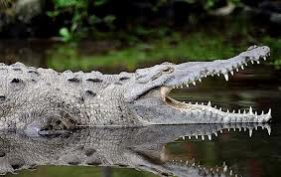
When it comes to sharks there are many different species and not all of them attack humans, although Hollywood movies might have you thinking otherwise. There is an average of one death per year over the last 50 years. An interesting fact about sharks is that they are immune to all known diseases.

Then there’s the crocodile. There are two kinds of Australian crocodiles, the harmless freshwater crocodile and the dangerous saltwater crocodile. Crocodile attacks do happen, mainly on pets and livestock but unfortunately also on humans. About two accidents per year involving humans are fatal.

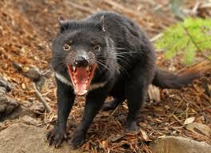
There are also other dangerous animals in Australia. For example, the Tasmanian Devil does exist, and it has the jaw strength of a crocodile. Sadly though, this animal is in danger of becoming extinct.

Finally, there is the deadliest of all Australian animals, responsible for an average of 10 deaths per year, and it's the European Honey Bee!

The School system

School is obligatory and for free for 10-12 years in Australia, depending on which state you live in. After the obligatory school years, Australians have to do two more years to be able to go to university. About 30 % of all children go to private schools which most often are religious ones. The school year starts in January or February and ends in December. Most Australian schools use school uniforms.
In Australia, you have to pay to go to University and it is fairly expensive for foreign students. Even so, Australia has plenty of international students, and nearly 1/3 of all university students are not Australians. Most of them are Asians. (In Sweden, about 1/4 are foreign students.)

Dreamtime
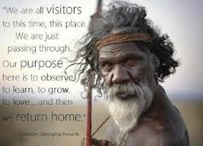
Australian Aboriginal mythology

The first inhabitants of Australia and keepers of the oldest continuous culture in the world, Aboriginal Australians, have a rich and often mysterious civilization that we are only just starting to understand and appreciate.
Aboriginal Australian culture dates back over 60,000 years to a period known in Aboriginal-English as the Dreamtime, but every one of the numerous Aboriginal nation groups spread across the continent and beyond has their own term for it.
Dreamtime is a place beyond time and space in which the past, present, and future exist wholly as one. Tribespeople could enter this alternate universe through dreams or various states of altered consciousness, as well as death.
Archaeological studies have revealed much about human origins in Australia, but it is the Dreamtime stories -- passed down by oral tradition - that provide the most fascinating insight into this ancient civilization.

Write 10 questions about this text and ask your desk friend to answer the them.

