Northern Ireland
Facts

About 1.8 million people live in Northern Ireland and the name of the capital is Belfast.
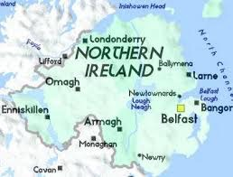
If you read the text about the UK, you'll know that Northern Ireland is a province of the United Kingdom. When Ireland won independence from Britain and became a republic in 1922, the north-eastern corner stayed under British rule.
Dividing Ireland led to many conflicts. The Troubles began in the 1960s and went

on for more than thirty years. During those years, people associated Northern Ireland with bombings and violence. This period claimed over 3,000 lives and more than 50,000 people were injured. The Good Friday Agreement in 1998 put an end to the killings; however, tensions still remain between certain groups.

The IRA

The Irish Republican Army, the IRA, was the group fighting for Irish independence starting in the early 20th century. Its leader Michael Collins was the one who formed the strategy of the IRA. He was determined to avoid massive destruction, military and civilian losses. Instead he directed a guerilla war against the British by suddenly attacking and then just as suddenly withdrawing in order to minimize losses and maximize effects.
The IRA continued its war for independence during The Troubles, but stopped showing regard for innocent people's lives and started using terrorist attacks, such as bombings.
Of course, there’s much more to Northern Ireland than its history.

The Weather

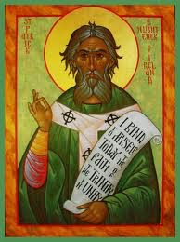
The Irish weather is a wonder in and of itself. It is jokingly said that the Irish tell the difference between a good day and a bad day by measuring the temperature of the rain.
The unpredictable weather, has led to the development of a collection of sayings to describe just how good or bad it is. So if you hear a local say: “She’s lashing out of the heavens” or “It’s bucketing down” he or she means that the rain is heavy. “S’terrible close” on the other hand means that it’s very humid and if it’s a nice day you could hear him or her say that “The sun’s splittin’ stones.”

Famous People from Northern Ireland

C.S Lewis, the author of the books about Narnia, is perhaps the person who is the most well-known to you. On the other hand, if you are a sports fan, you’ve probably heard of Rory McIlroy, the up- and- coming golfer.

Maybe the name George Best is familiar to you too, especially if you like football. Even though he played in the 60s and 70s, he's a legend and when he passed away, they even renamed the Belfast airport in his memory – The George Best City Airport.
If you’re into music you have most certainly heard of Van Morrison, and if you like acting you know who Kenneth Branagh is. He has directed and acted in many films, one of which is the British version of Wallander.

Fun Facts
Northern Ireland has a very young population. 46 per cent are under 30 years old. Another, maybe not so fun fact, considering its destiny, is that the famous ship Titanic was built in Belfast.

And here is an odd Irish birthday tradition; you lift the birthday child upside down and give his head a few gentle bumps on the floor for good luck. The number of bumps should correspond to the child’s age plus one.

Answer these questions, then hand in in SHOWBIE

Which country does Northern Ireland belong to?
What important thing happened in 1922?
Good Friday is a part of which holiday?
Who was Michael Collins?
When did the period called "The Troubles" officially end?
What does the saying “It’s bucketing down” mean?
Who was George Best?
What is the connection between Northern Ireland and the ship Titanic?
What is the connection between Narnia and Northern Ireland?

